**Prometheus Installation**

Step 1: Search for the Prometheus helm chart using the below command

helm search hub Prometheus

This command will list the following Prometheus helm chart

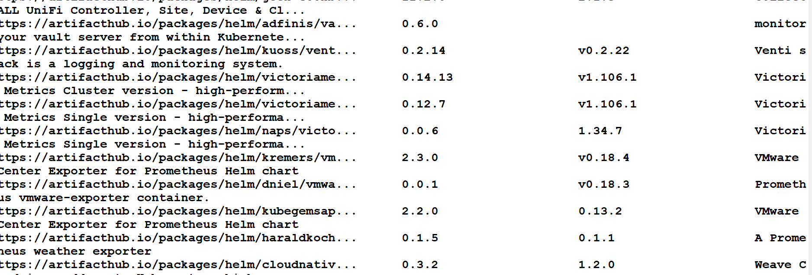

Check online

https://artifacthub.io/

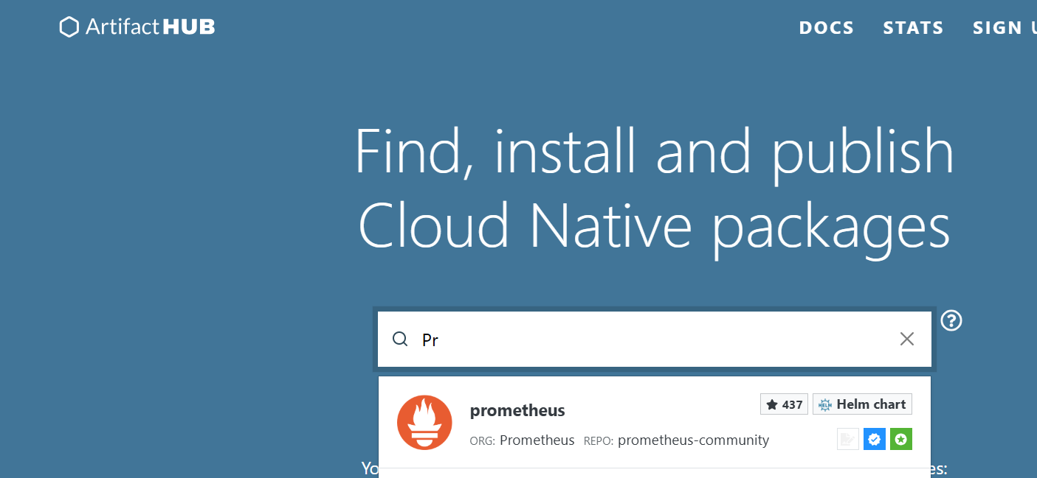

Run the following commands to add the Prometheus helm chart

helm repo add prometheus-community https://prometheus-community.github.io/helm-charts  
helm repo update

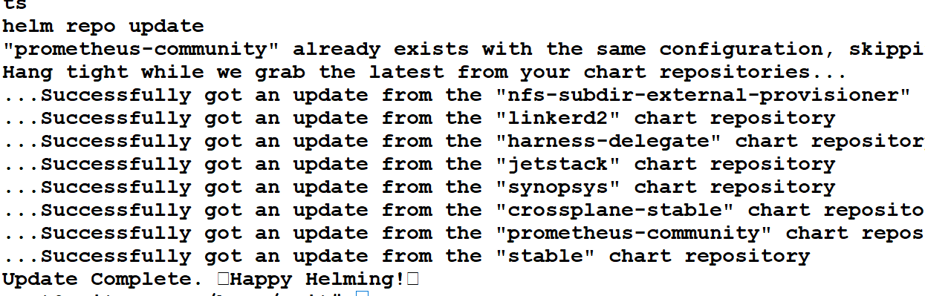

**Install Prometheus Helm Chart on Kubernetes Cluster**

helm install prometheus prometheus-community/prometheus

Run command to check

kubectl get service

Covert to NodePort

Kubectl edit svc prometheus

Uninstall Package

helm uninstall prometheus prometheus-community/prometheus

Grafana installation

helm search hub Grafana

helm repo add grafana https://grafana.github.io/helm-charts   
helm repo update

helm install grafana grafana/grafana

Get the secret

kubectl get secret --namespace default grafana -o jsonpath="{.data.admin-password}" | base64 --decode ; echo

Edit the svc type

kubectl edit svc grafana

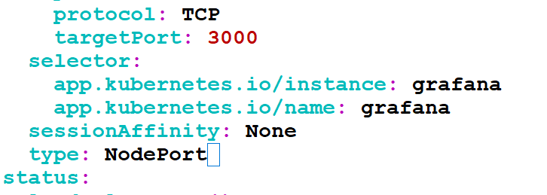

Note down the port

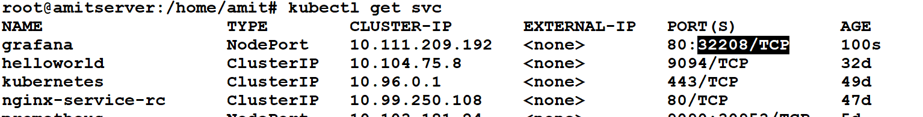

Login to Grafana portal

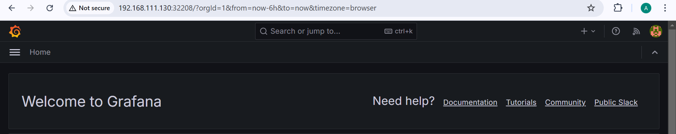

Click on datasource

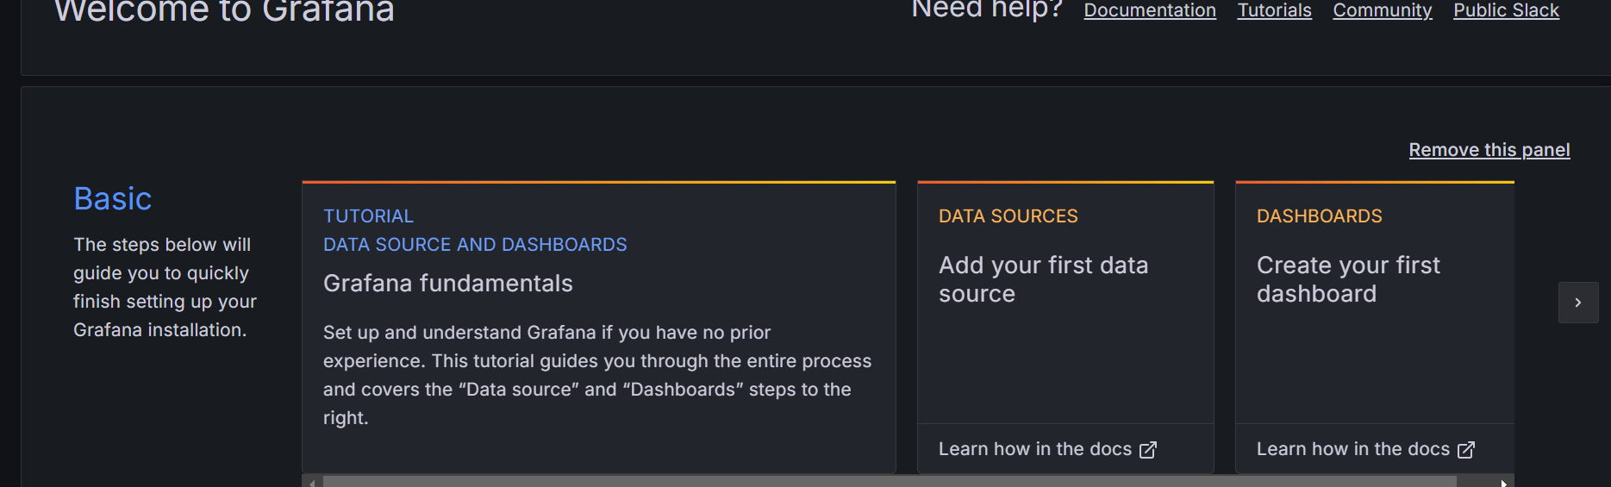

Select Prometheus

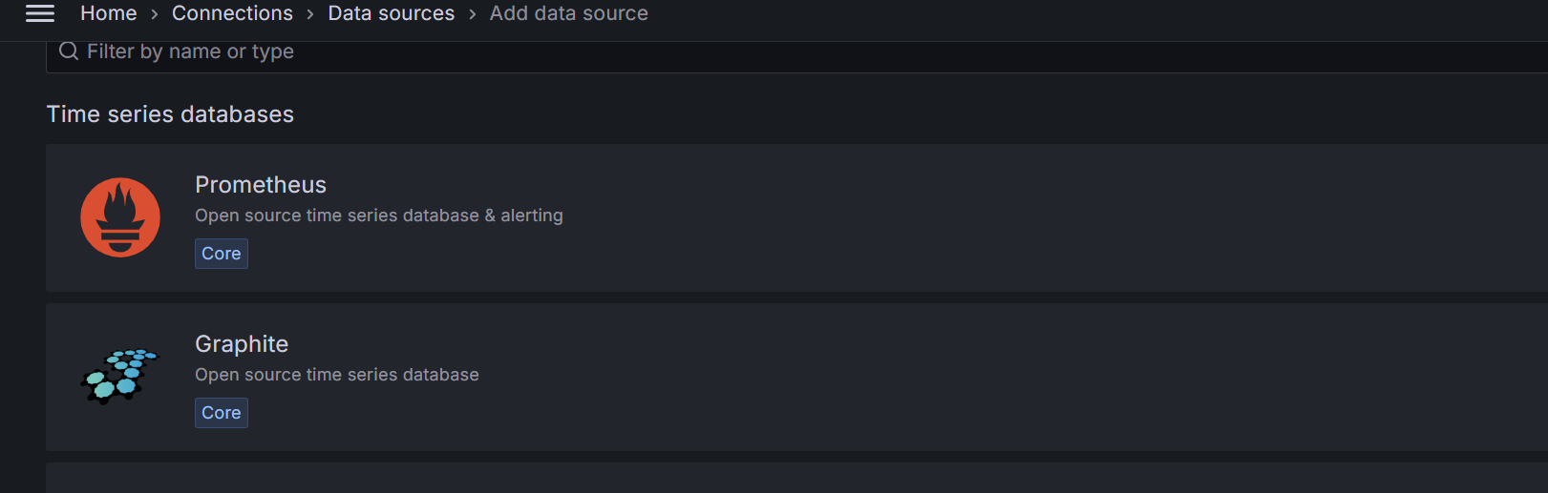

Provide IP of Prometheus

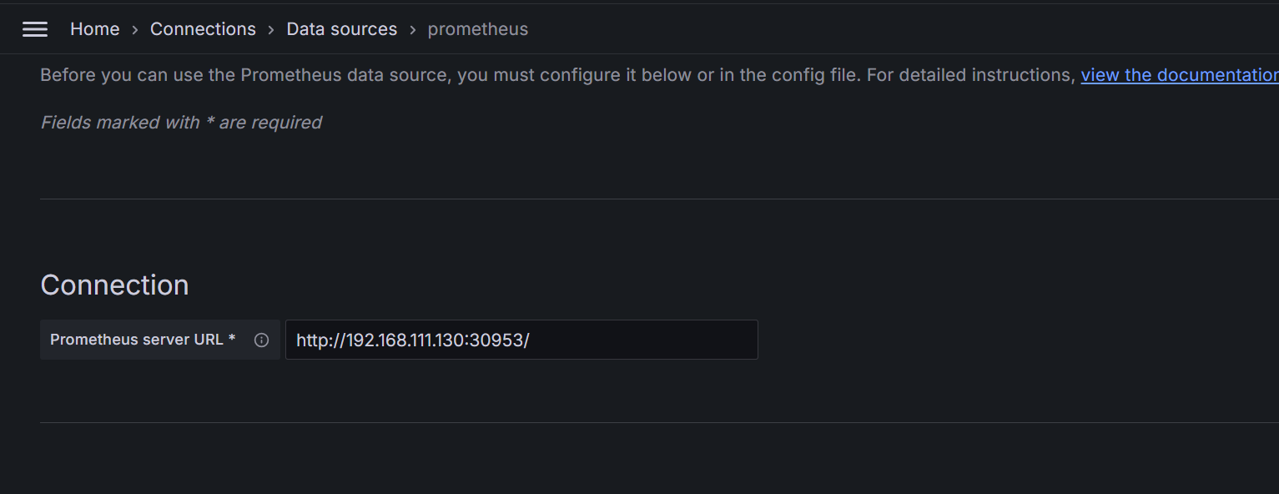

Setup using

<https://grafana.com/docs/grafana-cloud/monitor-infrastructure/kubernetes-monitoring/configuration/config-other-methods/prometheus/prometheus-operator/>